To-do:

* in Zeitplan einbauen: compare our results with the findings of previous studies
  + comparison with R-DeeP Database maybe?

Proteome-Wide Screen for RNA-dependent Proteins

Literature Review Data Analysis

[RNA-Binding Proteins: Molecular Targeted Therapy for Difficult-to-Treat Breast Cancer (scitechdaily.com)](https://scitechdaily.com/rna-binding-proteins-molecular-targeted-therapy-for-difficult-to-treat-breast-cancer/)

Important Links

science direct overview: hier finden sich interessante paper zum Thema

[RNA-binding Proteins - an overview | ScienceDirect Topics](https://www.sciencedirect.com/topics/neuroscience/rna-binding-proteins)

Open Questions (aus dem Sternburg Article)

* How does RBP targeting on mRNAs chance throughout development, in response to external changes and in disease?
* What are the changes in RBP bindinng at each individual mRNA site under varying conditions
* To what extent do the RBPs co-occupy the same mRNa moleuclae and what are the cooperative and antagonistic outcomes of their specific combinations

Introductory video

* RNA much more than just a template
* what is the role of non coding RNAs?
* Proteome screen reverses the screening process (Proteins are well

documented, we can use protein databanks for research about their properties)

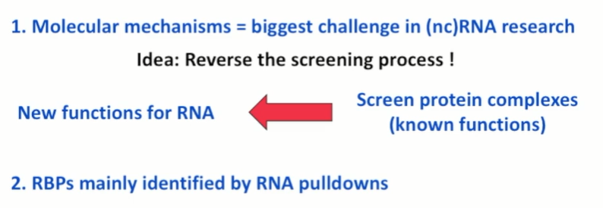

**GAP: small overlap between studies**

* common pull only contains 215 proteins (10% of RBP candidates)

need for orthogonal identification methods (what we want to figure out: can we predict, whether or not a specific protein is RNA binding by looking at its other properties when comparing with other protein databases (week 6 regression analysis and data modelling)

→ more studies shoud generate more overlap (cross-validation of results)

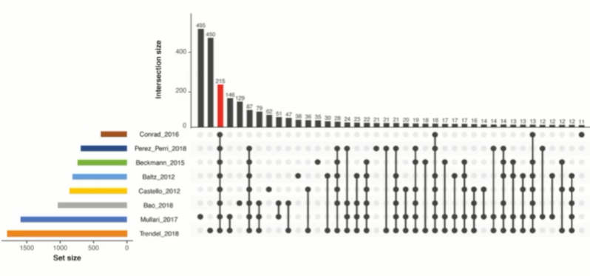

Change in definition: RNA-dependence instead of RNA binding

=identify proteins and complexes affected by RNA

=protein and protein complex whose molecular interactions depend on RNA (also includes RBP binding proteins)

Can this method find more RBPs?

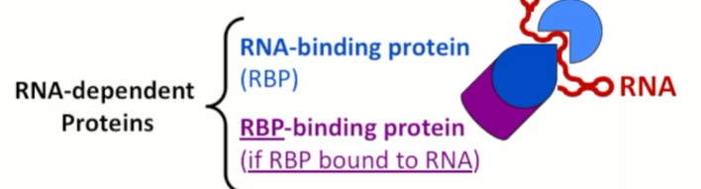 Can the proteins be regulated by RNA

Why should we care?

Because cancer is confusing

area with a high unmet medical need

finding new therapies will bring relief to patients and families

Experimental method

* Sucrose gradient does not require pre-treatment of the cells

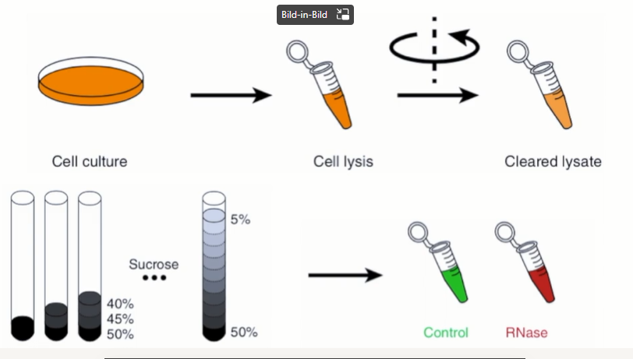

**if protein is RNA-dependent**

RNAse sample:

* individual proteins will dissociate and migrate into a different fraction each (sollten da mehrere Maxima sein?)

Dataset

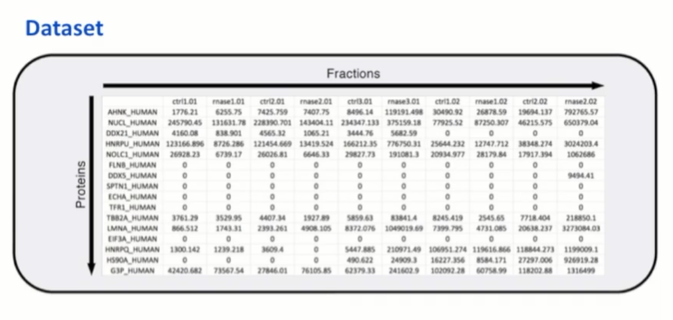

During Data Analysis

* classification of proteins depending on their shift

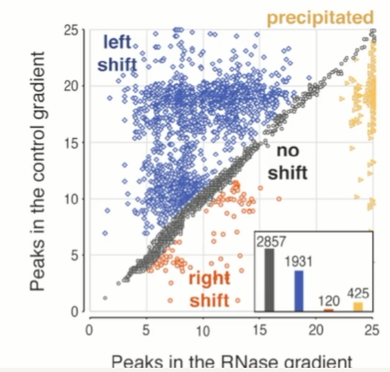

left shift: loss of interaction partners

right shift: gain of interaction partners

no-shift: RNA independent

precipitated: fraction 25 → pellet → also RNA dependent (why?)

Why should I care?

RBPs are dynamic

* RNA has no double helix, but is single stranded
* complementary base pairs bind via hydrogen bonds and form complex tertiary structures
* tertiary structures can are dynamic and can bind other molecules
* question that remains: How? What then? (What is the function?) How can we regulate it and how can we use this knowledge of RBPs?)

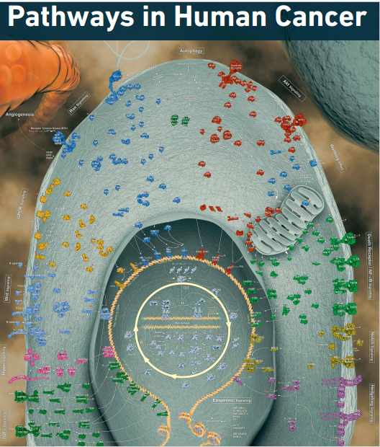

BUT: the more we understand the more potential there is for new therapeutics in an area with a high unmet medical need

* so far there has been research on cancer genomics (identification of tumor suppressor genes and oncogenes such as BRCA1/2)
* role of RNA remains not very well understood

Also: RBPs regulate key functions in RNA metabolism and regulate gene expression, defects are linked to severe diseases

# **Roles of RNA-binding proteins in immune diseases and cancer**

Author links open overlay panel

[ShigeruHashimoto1TadamitsuKishimoto](https://www.sciencedirect.com/science/article/abs/pii/S1044579X22000748#!)

* chronic inflammation and autoimmune dieseases (RBPs involved in the regulation of pro-inflammatory cytokines (IL-6 and TNF alpha) → **therapeutic strategies against cancer: targeting RBPs coupled with immunotherapy**

# **RNA-binding proteins in neurological diseases**

* [**HuaLin Zhou**](https://pubmed.ncbi.nlm.nih.gov/?term=Zhou+H&cauthor_id=24658850)**,** [**Marie Mangelsdorf**](https://pubmed.ncbi.nlm.nih.gov/?term=Mangelsdorf+M&cauthor_id=24658850)**,** [**JiangHong Liu**](https://pubmed.ncbi.nlm.nih.gov/?term=Liu+J&cauthor_id=24658850)**,** [**Li Zhu**](https://pubmed.ncbi.nlm.nih.gov/?term=Zhu+L&cauthor_id=24658850)**,** [**Jane Y Wu**](https://pubmed.ncbi.nlm.nih.gov/?term=Wu+JY&cauthor_id=24658850)

# **RNA-binding proteins in Mendelian disease**

[Alfredo Castello](https://pubmed.ncbi.nlm.nih.gov/?term=Castello+A&cauthor_id=23415593) [1](https://pubmed.ncbi.nlm.nih.gov/23415593/#affiliation-1), [Bernd Fischer](https://pubmed.ncbi.nlm.nih.gov/?term=Fischer+B&cauthor_id=23415593), [Matthias W Hentze](https://pubmed.ncbi.nlm.nih.gov/?term=Hentze+MW&cauthor_id=23415593), [Thomas Preiss](https://pubmed.ncbi.nlm.nih.gov/?term=Preiss+T&cauthor_id=23415593)

Was sind eigentlich Mendelian Diseases=disorders/diseases caused by mutation in one gene

Zusammenfassung des Abstracts

* RBPs: critical effectors of gene expression
* form regulatory networks that help to maintain cell homeostasis

RNA-binding proteins in human genetic disease

Fátima Gebauer # 1 2, Thomas Schwarzl # 3, Juan Valcárcel 4 5 6, Matthias W Hentze 7

war auch Teil der vorgegebenen Literatur

Abstract:

* RBPs critical effectors of gene expresion
* RBPS assemble with RNa to form ribonucleoprotein particles
* dynamic
* RNP composition changes according to the maturation/functional state of RNA and the cellular context
* RBPs regulate all aspects of RNA life, including transcription, splicing, modification, intracellular trafficking, translation and decay
* RBPs are evolutionary conserved

RBPs in genetic disease (Mendelian and somatic muatons)

* mainly diseases of the nervous system (RBPs are associated with nervous system development

RBP targeting therapeutics

* problems:
  + no clear active site
  + high structural similarity between individual membrers of RBD families
  + siginificant fraction of unstrucured regions
* e.g. compounds that inhibit pre-mRNA splicing (anti-proliferative, pro apoptotic effect)
* using structural data to aid in drug development
* **discoveries with translational potential**

# **RNA-binding proteins in neurological diseases**

[HuaLin Zhou](https://pubmed.ncbi.nlm.nih.gov/?term=Zhou+H&cauthor_id=24658850), [Marie Mangelsdorf](https://pubmed.ncbi.nlm.nih.gov/?term=Mangelsdorf+M&cauthor_id=24658850), [JiangHong Liu](https://pubmed.ncbi.nlm.nih.gov/?term=Liu+J&cauthor_id=24658850), [Li Zhu](https://pubmed.ncbi.nlm.nih.gov/?term=Zhu+L&cauthor_id=24658850), [Jane Y Wu](https://pubmed.ncbi.nlm.nih.gov/?term=Wu+JY&cauthor_id=24658850)

Zusammenfassung Abstract:

* neurological diseases

# RNA-Binding Proteins Hold Key Roles in Function, Dysfunction, and Disease

[Sophia Kelaini](https://www.ncbi.nlm.nih.gov/pubmed/?term=Kelaini%20S%5BAuthor%5D&cauthor=true&cauthor_uid=33923168), [Celine Chan](https://www.ncbi.nlm.nih.gov/pubmed/?term=Chan%20C%5BAuthor%5D&cauthor=true&cauthor_uid=33923168), [Victoria A Cornelius](https://www.ncbi.nlm.nih.gov/pubmed/?term=Cornelius%20VA%5BAuthor%5D&cauthor=true&cauthor_uid=33923168), and [Andriana Margariti](https://www.ncbi.nlm.nih.gov/pubmed/?term=Margariti%20A%5BAuthor%5D&cauthor=true&cauthor_uid=33923168)

* RBPs exert control through differing expression levels, cellular localization and post-transcriptional alterations
* regulation is reliant on micro-environment and extracellular events 8stress, metabolism)
* dysfunciton can lead to diabetes, cardiovascular disease and other

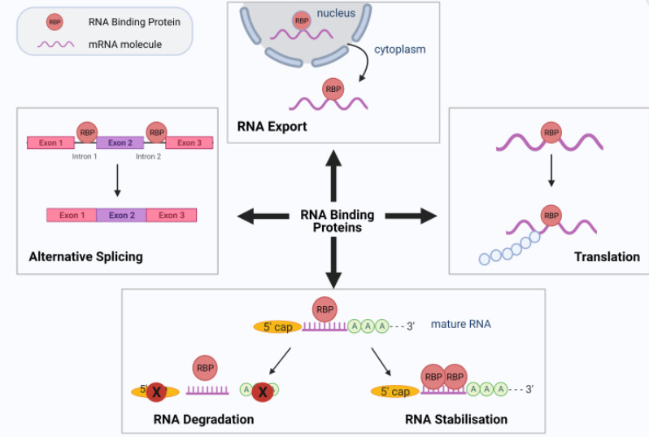

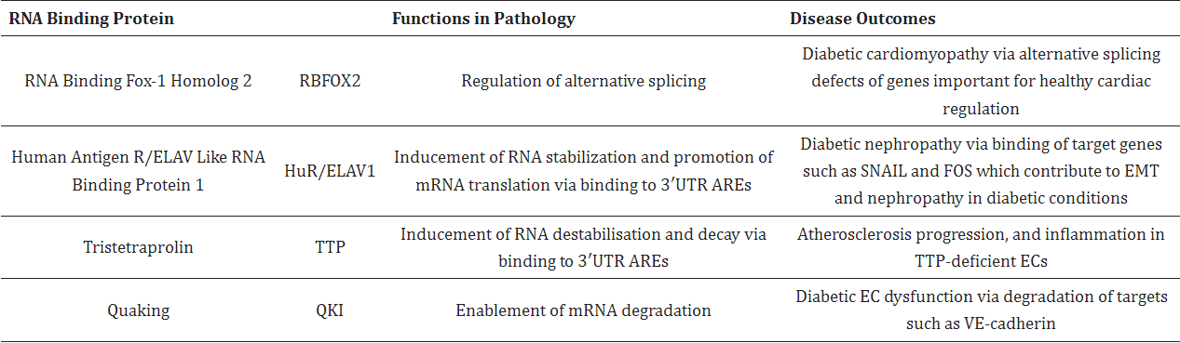

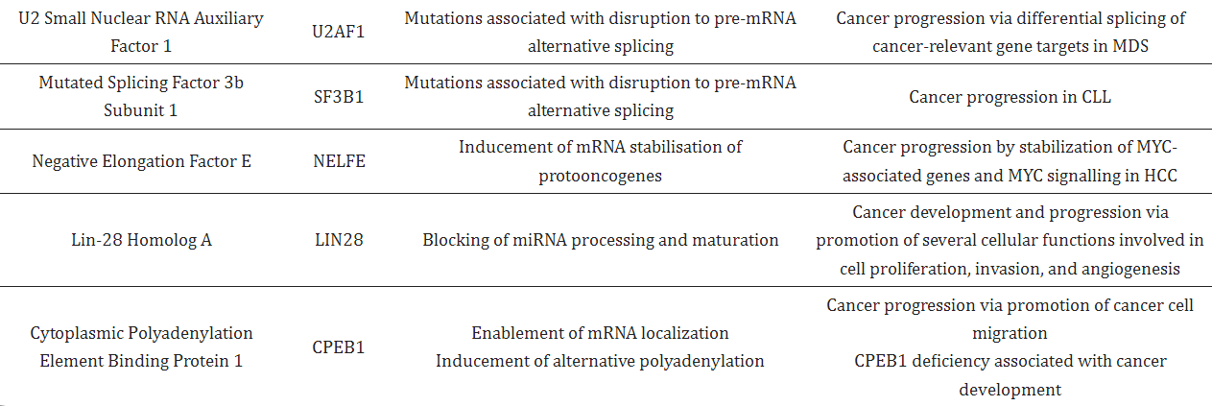

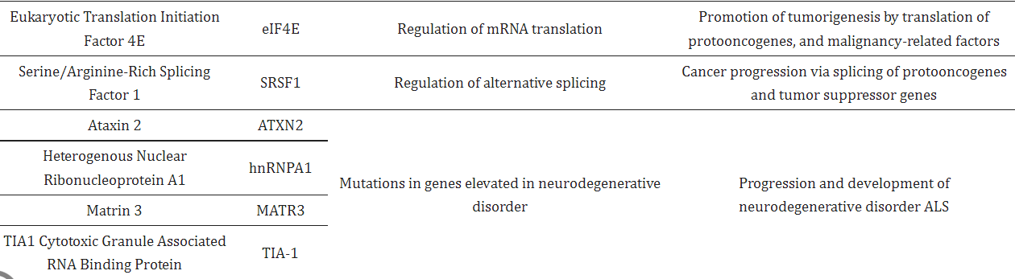

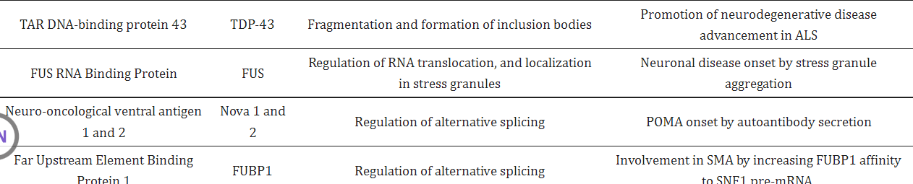

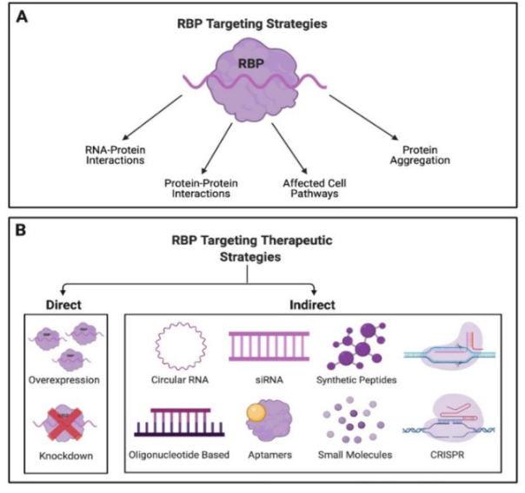

Vorgegebene Literatur

# **Identification, quantification and bioinformatic analysis of RNA-dependent proteins by RNase treatment and density gradient ultracentrifugation using R-DeeP**

Anmerkung: Paper war nicht frei verfügbar, deshalb hier nur eine Zusammenfassung des Abstracts

* several proteome wide studies dedicated to the identification of RNA binding protein
* RDeeP: approach built on RNa dependence=ability of a protein to engage in protein complexes only in the presence of RNA (direct/indirect RNA interaction)
* **provides quantitative information** of the fraction of a protein associated with RNA
* sucrose gradient method is independent of potentially biased purification procedures
  + cellular lysate fractionation by density gradient ultracentrifugation
  + analysis by proteome-wide mass spectrometry (or individual western blotting)
* identification of differences in apparent molecular weight and height

Paper Maiwen

Anmerkung: genaue Beschreibung der Methodik, wir werden vor allem mit diesem Paper arbeiten

**R-DeeP: Proteome-wide and Quantitative Identification of RNA-Dependent Proteins by Density Gradient Ultracentrifugation**

Method Summary

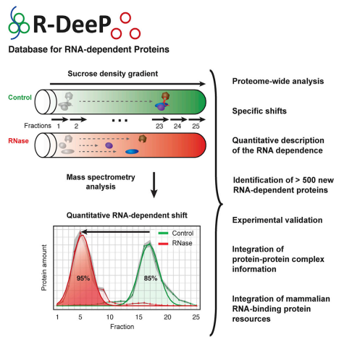

Summary:

* major challenges in RNA biology: specific identification of RNA-binding proteins and RNA-associated protein functions
* new definition: RNA dependent instead of strictly RNA binding

Picture of RNA dependence

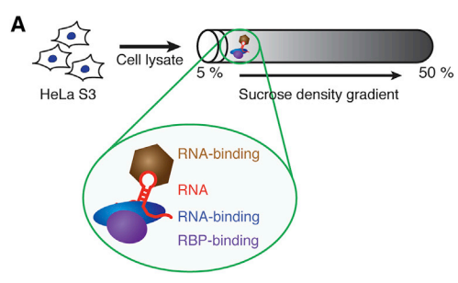

Several Proteins are not RNA binding but RNA dependent (might have been missed out by previous studies) so we hope to detect new RNA dependent proteins (which are mainly RNA interacting)

→ großes Potenzial dieser Methodik

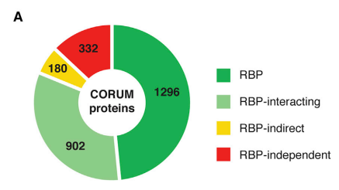

* identification of 1,784 RNA-dependent proteins (537 new ones)

transcription factor CTCF is completely RNA dependent (vielleicht finden wir auch sowas, also entdecken, dass ein bekanntes Protein im Zellzyklus wahrscheinlich RNA dependent ist)

* also quantitative nature of RBPs
* goal:future functional discovery of RNA bindign proteins

Introduction

* RBPs decide what happens with the RNA transcript
* RNAs affect fate of proteins (--> wechselseitige dynamische beziehung)
* dynamic interaction between RBP and RNA responds to cellular and environmental stimuli
* key functions in RNA metabolism and the regulation of gene expression, defects have devastating effects
* RBPs also associate with non-coding RNAs
* lncRNAs are associated with cancer (Wie genau?)
* → proteome wide, enrichment-free, quantitative screen for proteins whose interactome depends on RNA
* characterization of the compelte RNA dependence of transcription factor CTCF, RNA as an improtantfactor of recruiting CTCF to chromain

Results

* expectation: RNA dependent proteins migrate to different positions in a sucrose density gradient in the presence/absence of RNA
* each protein shows specific distribution through the gradient
* shift between fractions: : RNA dependence
* RNase digested RNA to a size < 100nt

characterizing shifts

* position of maxima in the control and RNase treated gradients (>1 fraction)
* amount of protein shifting (area under the Gaussian fit curve)
* distance and direction of the shift
* amplitude difference at each maximum between control and RNAse fitted curves
* statistical significance of the difference (FDR <0.05)

further investigation of proteins

* isoelectic point
* low complexity domain (??) contents
* amino acid composition
* protein domains
  + - shifting proteins had a slightly higher pI
    - significantly enriched in disorder promoting amino acids) and positively charged amino acids
    - similar distribution of LCD lengths
    - left shifted proteins were enriched in prtoein domains linked to RNA binding
    - **right-shifted and precipitated proteins were enriched in actin family domains (IPR004000) and zinc finger-related domains (wir möchten sehen, ob sich das auch bei unseren Zellen finden lässt, und wenn ja, inwieweit sich dass in den einzelnen Phasen des Zellzyklus ändert)**

R-DeeP Analysis of Protein Interaction Networks

* comparison with CORUM database
* analysis of protein complexes can be possible, because subunits share a common peak in the presence of RNA

Quantitative Analysis

* RNA independent/partially RNA dependent/ completely RNA dependent
* *Almost all partially shifting proteins were characterized by the presence of a smaller shifting control peak and a larger non-shifting control peak to which the proteins from the smaller peak shifted. The smaller peak, lost upon RNase treatment, corresponded to the RNA-dependent fraction of the protein. The larger control peak represented the RNA-independent fraction of this protein.*
* fully shifting proteins were enriched in LCD and canonical protein domains linked to RNA binding
  + fully shifting proteins resemble more classical RBPs
  + partially shifting proteins have a wide spectrum of domains and functions

Example of CTCF (good example but not necessarily important for project proposal)

Discussion

* **strategy to gain insight on RNA function by protein analysis (potential for uncovering new molecular pathways)**
* right shifts
  + rare
  + lowest average pI
  + assumption: gain of interaction partners after RNA loss (new binding sites are available, repulsive RNA charges are diminished)

problem with this approach: not able to determine the site of interaction

* cells are lysed (technically not in their native state anymore, intracellular complexes could be separated during lysis)
* weak/short interactions migh be lost during centrifugation

BUT

* direct/indirect binding
* identifies RNA that does nto crosslink with UV and does not link to polyadenylated RNAs
* quantitative analysis

Theoretischer Hintergrund

# Global Approaches in Studying RNA-Binding Protein Interaction Networks

* [Erin L. Sternburg](https://www.cell.com/trends/biochemical-sciences/fulltext/S0968-0004(20)30063-3?_returnURL=https%3A%2F%2Flinkinghub.elsevier.com%2Fretrieve%2Fpii%2FS0968000420300633%3Fshowall%3Dtrue#)
* [Fedor V. Karginov](https://www.cell.com/trends/biochemical-sciences/fulltext/S0968-0004(20)30063-3?_returnURL=https%3A%2F%2Flinkinghub.elsevier.com%2Fretrieve%2Fpii%2FS0968000420300633%3Fshowall%3Dtrue#)

Introduction:

* stable ribonucleoproteins/transient interaction
  + **bei einem Vergleich mit dem 2. Datensatz wäre vielleicht der Fokus auf transient interactions im Verlauf des Zellzyklus interessant.**
  + sequence specific/structure specific/non specific
  + spatially, and temporally regulate mRNA expression in development and homeostasis
  + modullating RBP activity changes gene expression faster than transcription and enables fine tuned regulation of RNA targets
  + “throughout their life cycle, mRNAs are continuously associted with large and dynamically changing sets of RBPs

Interaction Types and Mechanisms

* cooperative: binding of the RBP leads to increased binding of another RBP
* RBPs can destabilize the binding of another RBP: antagonistic interaction (direct competition, steric hindrance)
  + binding of the RBP changes the secondary structure of RNA
  + “combinations of cooperative or antagonitsic interactions provide increased flexibility in regulating the expression of a given mRNa, depending on cellular context. Such combinatorial effects also serve as safeguards to misregulations, where redundant regulatory inputs can control a circuit”
  + “interactions between RBPs are highly context dependend and employ different mechanisms”...”indicating, that these interactions are affected by their local environment”
  + Unterschiedung nuclear RBPs/Cytoplasmic RBPs
  + “RBPs that are involved in common regulatory processes tend to co-localize to the same general region (5’ and 3’UTR, coding sequence, splice sites)
  + “RBPs can simultaneoulsy participate in several kinds of interactiosn and their combination dictates the full cellular regponse

Zusatz

Sucrose Gradient Centrifugation

* overlaying lower concentrations of sucrose on higher concentrations in centrifuge tube
* sample of interest is placed on top of the gradient
* **particles travel through the gradient until they reaches the point in the gradient at which their density matches that of the surrounding sucrose**
* sucrose acts as a cushion → collection of morphologically intact particles

# **Role of RNA modifications in cancer**

[Isaia Barbieri](https://pubmed.ncbi.nlm.nih.gov/?term=Barbieri+I&cauthor_id=32300195) [1](https://pubmed.ncbi.nlm.nih.gov/32300195/#affiliation-1) [2](https://pubmed.ncbi.nlm.nih.gov/32300195/#affiliation-2) [3](https://pubmed.ncbi.nlm.nih.gov/32300195/#affiliation-3), [Tony Kouzarides](https://pubmed.ncbi.nlm.nih.gov/?term=Kouzarides+T&cauthor_id=32300195)

# **RNA-Binding Proteins in Cancer: Functional and Therapeutic Perspectives**

[Donghee Kang](https://pubmed.ncbi.nlm.nih.gov/?term=Kang+D&cauthor_id=32967226) [1](https://pubmed.ncbi.nlm.nih.gov/32967226/#affiliation-1) [2](https://pubmed.ncbi.nlm.nih.gov/32967226/#affiliation-2) [3](https://pubmed.ncbi.nlm.nih.gov/32967226/#affiliation-3), [Yerim Lee](https://pubmed.ncbi.nlm.nih.gov/?term=Lee+Y&cauthor_id=32967226) [1](https://pubmed.ncbi.nlm.nih.gov/32967226/#affiliation-1) [2](https://pubmed.ncbi.nlm.nih.gov/32967226/#affiliation-2), [Jae-Seon Lee](https://pubmed.ncbi.nlm.nih.gov/?term=Lee+JS&cauthor_id=32967226)

Abstract:

* RBPs regulate gene expression through post-transcriptional regulation (e.g. modulation of miRNA processing)
* many RBPs are known to be deregulated in cancer
* dysfuntion of RBPS can lead to malfunctioning gene regulation proliferation apoptosis, angiogenesis, senescence and Epithelial-mesenchymal transition/invasion/metastasis

Figures

RBPs in Cancer

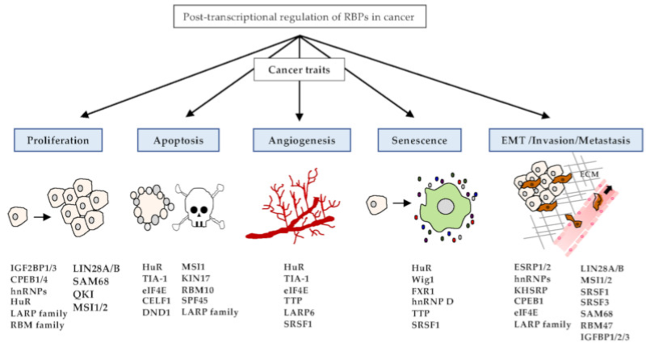

RBPs in posttranscriptional regulation of gene expresion in cancer

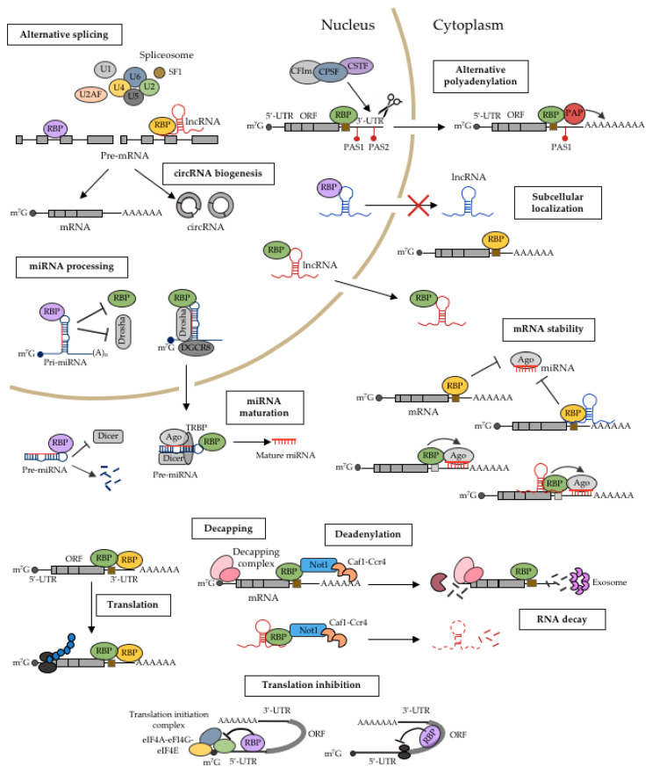

# **RNA-Binding Proteins in Cancer: Functional and Therapeutic Perspectives**

[Donghee Kang](https://pubmed.ncbi.nlm.nih.gov/?term=Kang+D&cauthor_id=32967226) [1](https://pubmed.ncbi.nlm.nih.gov/32967226/#affiliation-1) [2](https://pubmed.ncbi.nlm.nih.gov/32967226/#affiliation-2) [3](https://pubmed.ncbi.nlm.nih.gov/32967226/#affiliation-3), [Yerim Lee](https://pubmed.ncbi.nlm.nih.gov/?term=Lee+Y&cauthor_id=32967226) [1](https://pubmed.ncbi.nlm.nih.gov/32967226/#affiliation-1) [2](https://pubmed.ncbi.nlm.nih.gov/32967226/#affiliation-2), [Jae-Seon Lee](https://pubmed.ncbi.nlm.nih.gov/?term=Lee+JS&cauthor_id=32967226)

Wikipedia Overview

* various structural motifs: RNA recognition motif, dsRNA binding domain, zinc finger
* cytoplasmic and nuclear proteins
* post-transcriptional control of RNAs: splicing, polyadenylation, mRNA stabilization, mRNA localization and translation
* RBPS regulate RNA metabolism

Funcitons of RBPs

* alternative splicing
* RNA editing (ADAR, extends diversity of gene products)
* Polyadenylation (nuclear transport, translation efficiency and stability): protein CPSF
* nuclear export
* mRNA localization

Protein/RNA interaction

* highly specific recognition of their RNA targets
* can bind from transcription to degradation/only transiently
* RNA can change shape danymically

RRM: RNA recognition mofif

* most common
* 75-85 amino acids
* four stranded beta-sheet (Kristallstruktur/Modell irgendwo finden?)
* contacts 2-3 nucleotides
* strong bidning affinity & specificity achieved through interaction between inter-domain linker
* high plasticity

Double stranded RNA binding motif

* 70-75 amino acids
* RNa processing, RNA localizatio, RNA interference, RNA editing
* adapted to the 2’OH group and phosphate oxygen → binds specifically to dsRNA instead of dsDNA

Zinc finger

* beta-beta-alpha protein fold
* beta hairpin and alpha helix are joined via Zn2+
* interaction between intermolecular hydrogen bonds and Watson crick edges on RNa bases enables RNA binding

RBPs in embyronic development

* development of somatic tissues (neurons, hypodermis, muscles and excretory cells)
* provides timing cues for developmental events
* challenge: function is difficult to find out bc it is difficult to identify the target
* most RBPs have mutliple RNa targets

ZBP1: regulated dendritogenesis in hippocampal neurons Perycz M, Urbanska AS, Krawczyk PS, Parobczak K, Jaworski J (April 2011). ["Zipcode binding protein 1 regulates the development of dendritic arbors in hippocampal neurons"](https://www.ncbi.nlm.nih.gov/pmc/articles/PMC6622686). *The Journal of Neuroscience*

Role in Cancer

* RBPs are markedly dysregulated across human cancers
* downregulation in tumors related to normal tissues
* expressed differently in cancer types
* dysregulation can cause abberant alternative splicing in cancer

Current research

* Sam68
  + loss: abnormal posttranscriptional regulation → neurological disorders (fragile X-associated tremor/ataxia syndrome)
  + Sam68 interacts with the mmRNA encoding beta-acting (regulates synaptic formation fo the dendritic spines with its cytoskeletal components, critical role in synapse number)
  + Klein ME, Younts TJ, Castillo PE, Jordan BA (February 2013). ["RNA-binding protein Sam68 controls synapse number and local β-actin mRNA metabolism in dendrites"](https://www.ncbi.nlm.nih.gov/pmc/articles/PMC3581878). *Proceedings of the National Academy of Sciences of the United States of America*.

Low complexity regions of proteins

* regions in protein seuqences that differ from the composition and complexity of most proteins → normally associated with globular structure
* can form secondary structures
* were orignially thought to be unstructured, flexible linkers
* genaue Funtkion aber unbekannt

Aktin

Wikipedia (Alberts als Quelle angeben)

* microfilaments in the cytoskeleton
* muscle contraction, cell motility (which we need for cancer!!), cell division, cytokinesis
* dynamic, cell can remodel itself in response to internal and exteranl stimuli
* Central role in the invasivity of cancer cells

Nuclear Actin

* transcription: involved in chromatin reorganisation
* interacts with RNA polymerase I, IIaand II
* component of the cromatin remodeling complex

Functions

* cell division. contractile ring completes cytokinesis
* Actin is an ATPase. enzyme that hydrolyzes ATP

Actin binding proteins:

* involved in polymerization, depolymerization, stability aand organiation
* some proteins bind & stabilize the end (CapZ, Tropomodulin)

Pathology in cytooplasmic actins:

* ACTB (beta-actin)
* variation by alternative splicing
* carcinomas, nervous system malformation, tumor invation

# The Role of the Actin Cytoskeleton in Cancer and Its Potential Use as a Therapeutic Target

* [Simon Brayford](https://link.springer.com/chapter/10.1007/978-1-4939-2904-7_16#auth-Simon-Brayford),
* [Galina Schevzov](https://link.springer.com/chapter/10.1007/978-1-4939-2904-7_16#auth-Galina-Schevzov),
* [Julien Vos](https://link.springer.com/chapter/10.1007/978-1-4939-2904-7_16#auth-Julien-Vos) &
* [Peter Gunning](https://link.springer.com/chapter/10.1007/978-1-4939-2904-7_16#auth-Peter-Gunning)

Abstract:

* maintaining cell shape and function
* alterations in the oragnisation of the cytoskeleton and changes in cellular morphology, motility and adhesiveness are characteristic features in cancer
* cytoskeletal microfilaments as promising targets for chemotherapy
* Problem: actin inibiting drugs can’t distinguish between normal cells and tumor cells
* **structure and function of actin cytoskeleton is regulated by associated actin binding proteins**

# **The actin cytoskeleton in cancer cell motility**

[Michael F Olson](https://pubmed.ncbi.nlm.nih.gov/?term=Olson+MF&cauthor_id=18498004) [1](https://pubmed.ncbi.nlm.nih.gov/18498004/#affiliation-1), [Erik Sahai](https://pubmed.ncbi.nlm.nih.gov/?term=Sahai+E&cauthor_id=18498004)

Abstract

* invasion into surrounding tissue, intravasation, extravasation and growth require cell motility
* driven by cycles of actin polymerization, cell-adhesion and acto-myosin contraction

# **Expanding horizons: new roles for non-canonical RNA-binding proteins in cancer**

Author links open overlay panel

[SamanthaMoore123Aino IJärvelin13IlanDavis1Gareth LBond2AlfredoCastello](https://www-sciencedirect-com.ubproxy.ub.uni-heidelberg.de/science/article/pii/S0959437X1730148X?via%3Dihub#!)

Abstract

* cancer development: stepwise accumulation of genetic lesions
* RBPs linked to cancer
* RBPs involved in a broad spectrum of cellular processes: stress response, metabolism
* **→ goal: new mechanistic understanding of cancer formation**

Introduction

* cancer mutations and dysregulation saffect most/all steps of RNA metabolism,
  + splicing
  + 3’ end processing
  + editing
  + stability
  + storage & localizatin
  + translation
  + biogenesis of small RNAs/miRNAs

→ mutations of RBPs can cause glbal changes in the transcriptome/proteome

also uncanonical.RBPS

* metabolic enzymes
* protein scaffolds
* antiviral factors

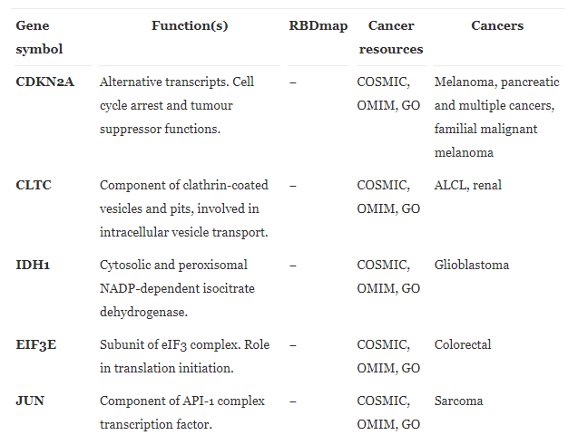

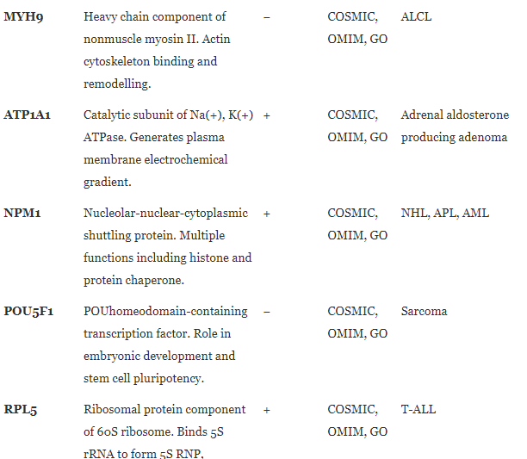

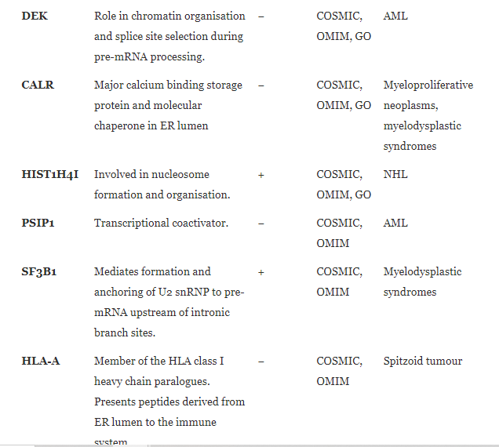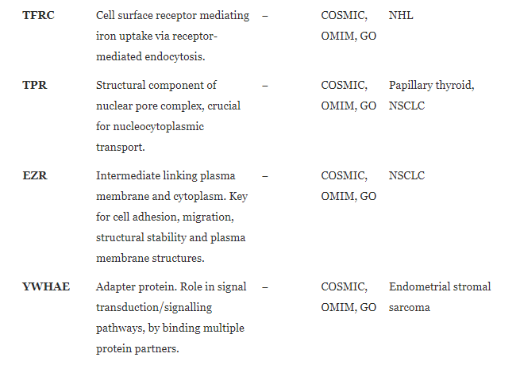

Chaperones & scaffolds

* cytoprotective and anti-apoptotic
* some of them are RBPs: correction of misfolded proteins
* plays role in the miRNA loading in RNA induced silencing complex (RISC)

Therapeutic Potential of RBPs

triple negative breast cancer:

[RNA-Binding Proteins: Molecular Targeted Therapy for Difficult-to-Treat Breast Cancer (scitechdaily.com)](https://scitechdaily.com/rna-binding-proteins-molecular-targeted-therapy-for-difficult-to-treat-breast-cancer/)

# **The RNA Binding Protein HuR: A Promising Drug Target for Anticancer Therapy (Anmerkung: sehr interessanter Ansatz, allerdings ist der Artikel nicht frei verfügbar, HuR kann aber als Beispiel für ein potenzielles therapeutic target verwendet werden)**

[Mingxia Wu](https://pubmed.ncbi.nlm.nih.gov/?term=Wu+M&cauthor_id=30381077) [1](https://pubmed.ncbi.nlm.nih.gov/30381077/#affiliation-1), [Christy W S Tong](https://pubmed.ncbi.nlm.nih.gov/?term=Tong+CWS&cauthor_id=30381077) [1](https://pubmed.ncbi.nlm.nih.gov/30381077/#affiliation-1), [Wei Yan](https://pubmed.ncbi.nlm.nih.gov/?term=Yan+W&cauthor_id=30381077) [1](https://pubmed.ncbi.nlm.nih.gov/30381077/#affiliation-1), [Kenneth K W To](https://pubmed.ncbi.nlm.nih.gov/?term=To+KKW&cauthor_id=30381077) [1](https://pubmed.ncbi.nlm.nih.gov/30381077/#affiliation-1), [William C S Cho](https://pubmed.ncbi.nlm.nih.gov/?term=Cho+WCS&cauthor_id=30381077)

* HuR: Human antigen R: RNA binding protein
  + regulates stability, translation and nucleus to cytoplsm shutteling of target mRNAs
  + HuR binds mRNa in the nucleus, escorts them to the cytoplasm, where it binds to protect the RNA from degradation

- several RNA recognition motifs: specificylla bind to adenylate and uridylate rich regions within the 3’UTR

target mRNAs encode proteins for cell growth, tumorigenesis, angiogenesis, tumor inflammation, invasion and metastasis

HuR overexpression: high-grade malignancy, poor prognosis

→ attractive target in cancer therapy: novel small molecule HuR inhibitors

diff article: HuR-targeted small molecule inhibitor exhibits cytotoxicity towards human lung cancer cells

[HuR-targeted small molecule inhibitor exhibits cytotoxicity towards human lung cancer cells.](https://pubmed.ncbi.nlm.nih.gov/28855578/)

Muralidharan R, Mehta M, Ahmed R, Roy S, Xu L, Aubé J, Chen A, Zhao YD, Herman T, Ramesh R, Munshi A.

Meredith Corley: How RNA-Binding Proteins Interact with RNA: Molecules and Mechanisms

* RNA binding domains in proteins
* multiple domains per RBP: can coordinate
* RBPs are enriched in intrinsically disordered regions
* RNA binding domains are heterogenous
  + lots of RBPs actually lack known RNA-binding domains (und es gibt noch die RNA dependent proteins, die gar nicht binden, aber mit Maiwens Methode erkennbar sind)

Protein-RNA molecular Interaction

* chemical moieties between protein residues and RNA nucleotides
* dynamical interactions

Hydrogen Bonds and Van der Waals Interactions

* RNA bases 2’OH (hat DNA nicht) and phosphodiester backbone can form hydrogen bonds and VdW interactions with proteins
* interact with protein side chain
* polar amino acids (Ser, Asn) and positively charged amino acids (Lys, Arg): strong ionic hydrogen bonds are often found in these interactions

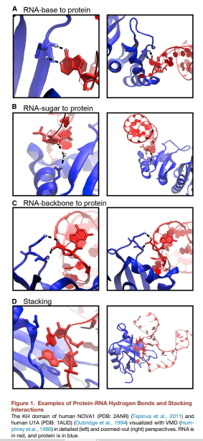

Hydrophobic and pi-Interactions and Stacking

* between RNA bases and hydrophobic side chains
* important stabilizing factors
* sequester hydrophobic residues and bases from solvent to form a hydrophobic core
* pi-interactions: betwwen nitrogenous base ring and pi-containing amino acid (aromatic residues Trp, His, Phe and Tyr and charged residues Arg, Glu and Asp)
  + strong interaction
  + provides stability
  + lots of stacking interactions in the U1A spliceosomal protein (also has RNA Polyadenylation inhibition element)

Differences to Protein-DNA interactions

* same preference for interacting residues: positively charged, polar reisdues
* 20% of RNA protein interaction occur with the 2’OH
* protein DNa interaction uses the phosphodiesterbackbone of the helical structure, RNA is not a helix
* RNAs have diverse tertiary structures (stem loops)
* dsRNA has a different helix than B DNA (RBPs interacting with dsRNA won’t also bind to DNA)
* but Zinc finger protein binds both DNA and RNA

Binding dynamics

* dnymic rearrangement
* RNA and protein: mostly local rearrangements during binding, backbone shifts, base, residues flipping out
* “upon inding the site of interaction becomes rigid, locking the molecules together, whereas adjacent elements in the two molecules loosen to balance the decrease in entropy”
* disordered regions adopt structure when RNA is bound
* tertiary flexibility of RNA

Protein-RNA prediction and Resources

* protein-RNA interfaces prefer positively charged residues
* (protein protein interfaces prefer polar residues)
* predictions: residue composition, conservation and solvent accessibility
* machine learning algorithms biases by available structure data
* “predictive algorithms should greatly benefit in the future from the characterization of novel-RNA binding domais and data from alternative structural techniques”

RNA binding domains

* most Rna binding domains are small
* combination of multiple RNA binding regions cumulatively enables RBPs to bind specific RNA regions
* Multiple RNA bidnign domains co-exist in ine RBP
* linker regions determine, whether adjacent RNA-binding domains bind independently/cooperatively
* some RNA binding domains are capable of mediating protein-protein interactions

RNA recognition motif (Kristallstruktur heraussuchen)

* most common domain
* 1% of all human proteins
* 90 amino acids
* 2 alpha helices against an antiparallel beta-sheet
* interact with 2-8 nt in the sssRNA
* severaal sequential stacking interactions and hydrogen bonsds with RNP motifs
* each RRM has sequence preferences (often degenerate sequences such as the Gu-rich tract)
* combination of consecutive RRMs in RBp dramatically increases binding affinity and specificity

K homology

* 70 amino acids
* recognizes 4 nt in ssRNA/ssDNA
* conserved GXXG RNA binding motif located between alpha 1 and alpha 2 helices
* RNA binding in the hydrophobic pocket, several hydrogen bonds coordinated by GXXG
* less stacking domains, weak micromolar affinities
* multiple KH domains can independently or syneergistically increase binding specificity

Domain Structure Images

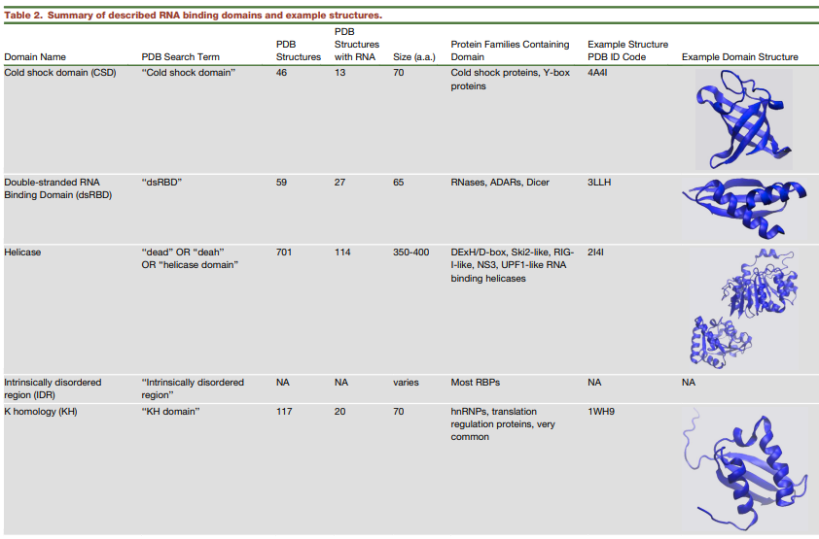

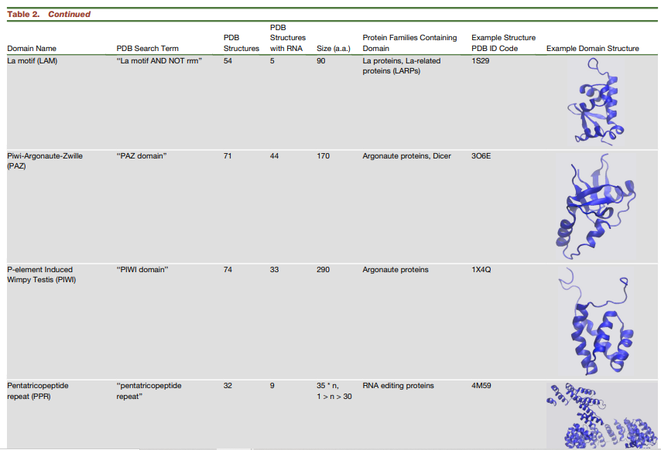

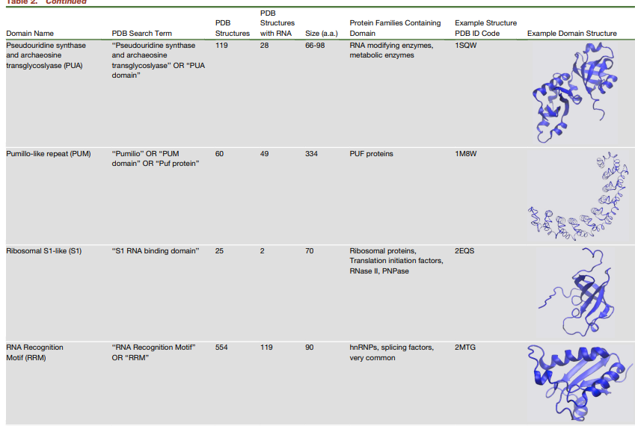

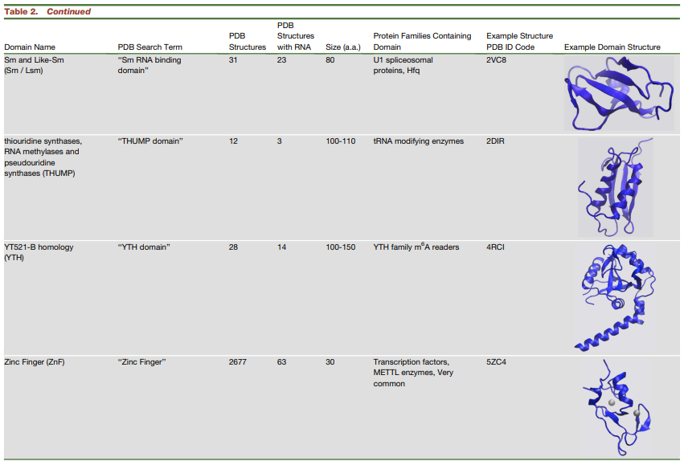

Zinc finger

* 20 amino acids
* beta,, beta alpha 2 topology
* residues in the beta hairpin turn and alpha helix are coordinated with Zn2+ ion
* bind DNA and RNA
* Histidine and Cysteine residues coordinate Zn 2+ atom
* Zink recognizes stem loop structures in ssRNA
* contacts formed with hydrogen bonds and the insertion of aromatic side chains that stack between bases
* “Modluar arrays of CCHH ZnFs have been successfully engineered to bind desired DNA sequences, thus designer ZnFs are thought to have potential directed binding of RNA sequences “

hier sind noch ein paar andere Beispiele aufgeführt, die jedoch sehr spezifisch sind und aus Zeit- und Platzgründen nicht hier aufgeführt sind

Double stranded RNA

65-70 amino acids

thrid most common RNA bidning domain

proteins with roles in viral protection, RNAi and cellular transport

dsRBDs often appear as tandem repeats

* specific recognition of A-RNA Helix

Piwi-Argonautre-Zwille and Piwi

* on opposite sites of the argonaute prtoeins
* facilitate binding of small interfering RNA and microRNA guides to mRNA targets

Intrinsically disordered regions

* unstructured
* often consist of repeats of arginine7serine (RS repeat)
* Arginine/Glycine (RGG box)
* arginine or lysine rich patches (R/K basic patches)
* can be the only binding domain in RBPs
* highly conserved
* not very sequence specific → high affinity for RNA is driven by electrostatic attraction of phosphodiester backbone

Amino Acid Preferences

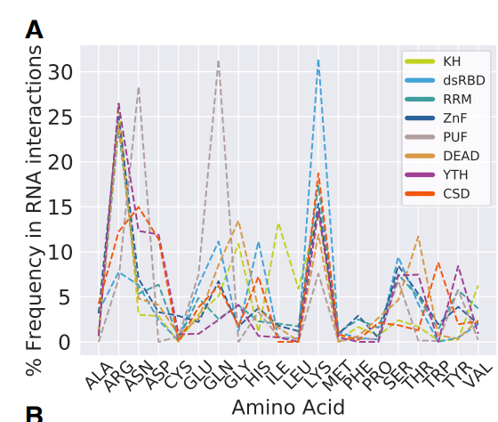

Regulation Mechanisms

* dynamic cellular context regulates the interaction
* “RNA/RBP abundance also affects the free energx of binding, where high abundance pushes the equation in favor of association”
* individual components of protein and RNA have different functions once associated
  + static binding/translocation/remodeling/modification
  + many RBPs statically bind specific RNA elements (often hairpin loops)
  + Helicases remove   
    RNA secondary structure (“scanning and unwinding”): manipulation of RNA structure is considered a non-covalent form of RNA
  + RNAs can also be chemically modified: e.g. adding methlgroups (base-pair stabilizatio from pseudouridine modifications and de-stabilization from inosine and m6A)
  + most extreme modifications: RBPs with nucleolytic activity (Argonaute, RNAses Dicer and RNAse II)

Conclusion

goals for the future: RNA binding site detection techniques, RBP synthetic design, role of RBPs in stress granules and neurodegenerative diseases

* areas benefit from a solid mechanistic nderstanding of protein-RNA target interactions

# **Actin binding proteins: their ups and downs in metastatic life**

Abstract:

* metastazing away from the primary tumor site cancer cells sill stimulate cellular motility
* regulation of cytoskeletal structures
* actin binding proteins play fundamental functions in regulating the dyamics of actin polymerization
* F-Actin Filaments play a central role in cellular migration

Actin in a migrating cancer cell

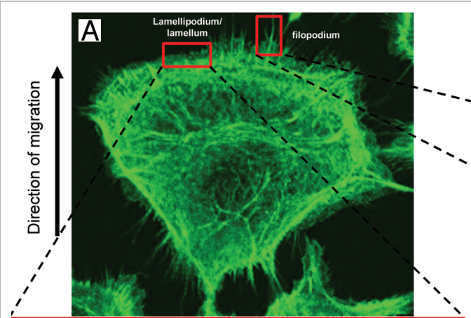

Examples of changing actin proteins in cancer

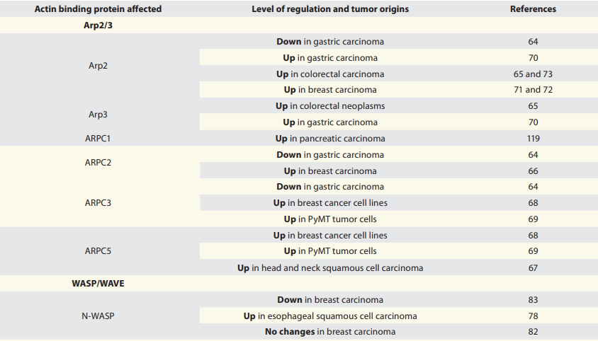

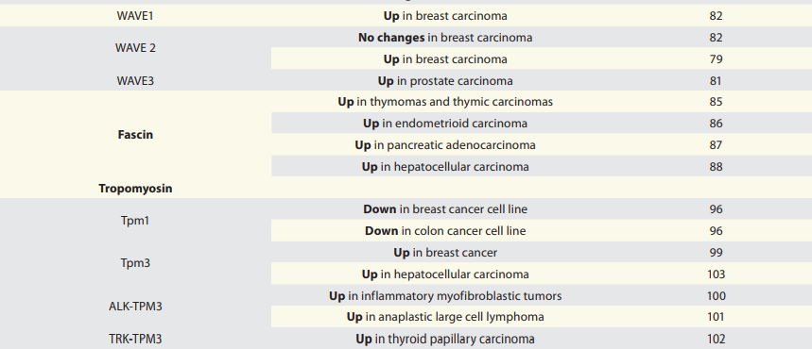

Actin and miRNA

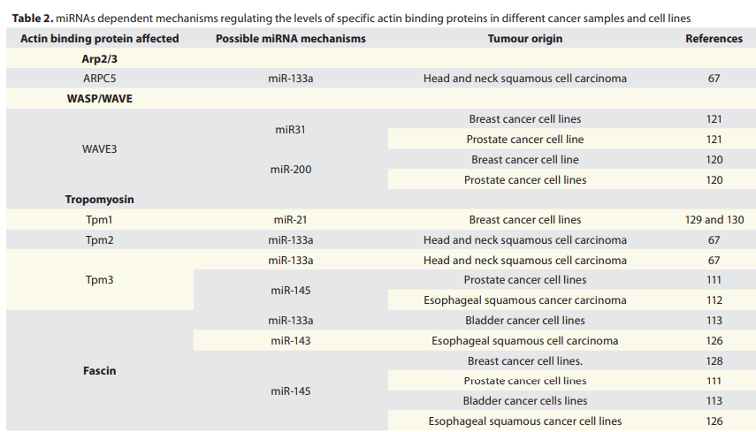

conclusion

* subset of actin binding proteins have now advancesd as hallmarks for carcinogenesis

# RNA-Binding Proteins: Molecular Targeted Therapy for Difficult-to-Treat Breast Cancer

[RNA-Binding Proteins: Molecular Targeted Therapy for Difficult-to-Treat Breast Cancer (scitechdaily.com)](https://scitechdaily.com/rna-binding-proteins-molecular-targeted-therapy-for-difficult-to-treat-breast-cancer/)

Scientific source

Reference: “Inhibition of YTHDF2 triggers proteotoxic cell death in MYC-driven breast cancer” by Jaclyn M. Einstein, Mark Perelis, Isaac A. Chaim, Jitendra K. Meena, Julia K. Nussbacher, Alexandra T. Tankka, Brian A. Yee, Heyuan Li, Assael A. Madrigal, Nicholas J. Neill, Archana Shankar, Siddhartha Tyagi, Thomas F. Westbrook and Gene W. Yeo, 2 July 2021, *Molecular Cell*.

[DOI: 10.1016/j.molcel.2021.06.014](https://doi.org/10.1016/j.molcel.2021.06.014)

Website Article

Anmerkung: ich muss noch gucken, ob es dazu wissenschaftliche Zitationen gibt

* RBPs can be potential targets in molecular targeted cancer therapy
* has the potential for treating triple-negative breast cancer
* 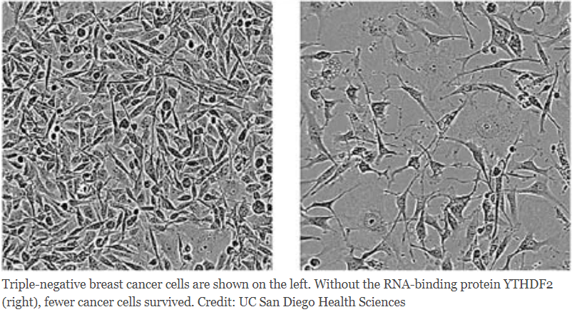
* targeted RBP: YTHDF2
  + RBP was removed from human triple-negative breast tumors transplanted into mice → tumors shrank approx. 10 fold in volume
  + Yeo found out that mutations in RBPs contribute to ALS
  + YTHDF2 deficient cancer cells die by stress induced apoptosis